A picture containing clipart

Description generated with very high confidence

Azure 103 Module 4

Hands On - 12

Azure Certification Training

[**support@intellipaat.com**](mailto:support@intellipaat.com)

**+91-7022374614**

**US: 1-800-216-8930(Toll Free)**

**Azure 103 Module 4 , Hands On – 12**

**Create NSG.**

**Step 1:** In Azure Portal search for Network Security Group and Click on it.

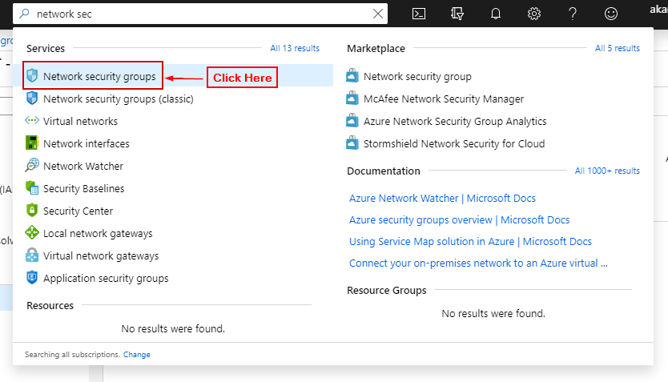

**Step 2:** Click on ‘+ Add’.

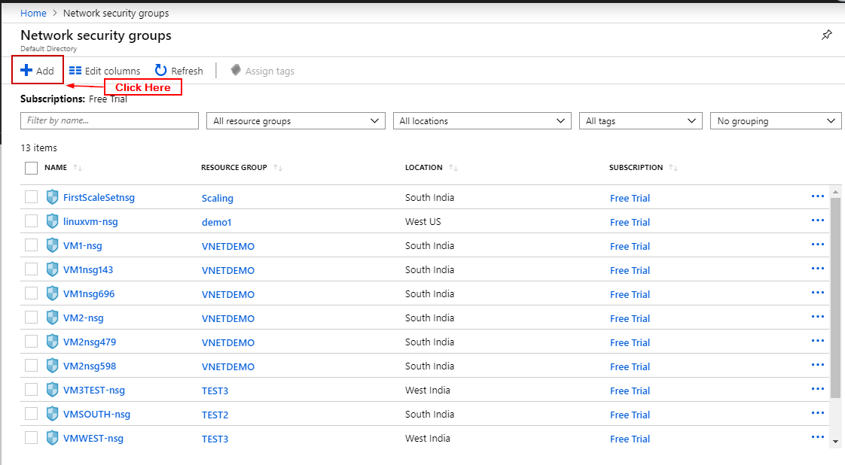

**Step 3:** Enter Details and click create.

